PRESS RELEASE

Date: September 2018

From: Laura Hamby, Event Contact 831-325-9615
tasteofsoquel@gmail.com
www.tasteofsoquel.org

Subject: TASTE OF SOQUEL, A Benefit for Second Harvest Food Bank
________________________________________________________________

10th ANNUAL!
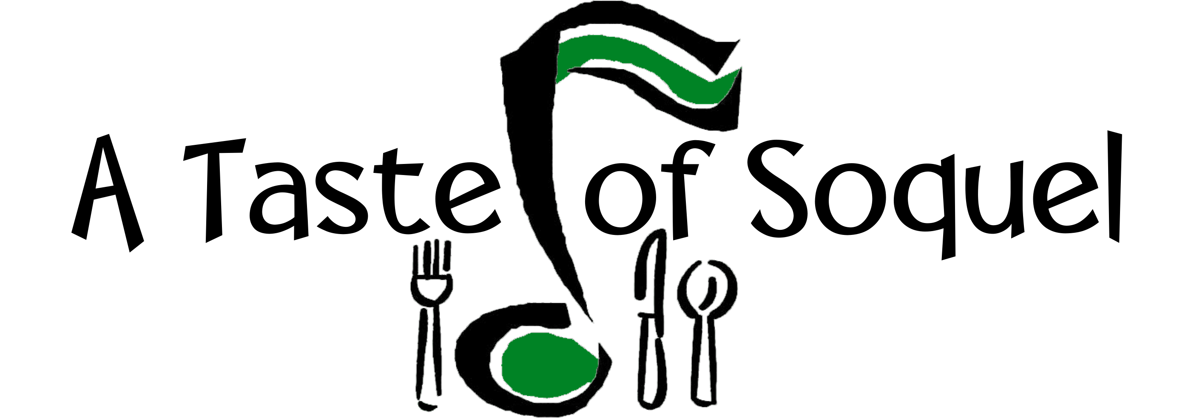

Food and Music for the Common Good

Saturday, September 22, 2018 11am – 4pm

Benefit for Second Harvest Food Bank

A TASTE of SOQUEL
Food and Music for the Common Good
Saturday, September 22, 2018 11am ~ 4pm
Benefit for Second Harvest Food Bank
A Taste of Soquel has raised over $75,500 (298,00 healthy meals) for families in Santa Cruz County! The TENth Annual A Taste of Soquel promises to be a fun filled day of Food & Music for the Common Good! The Congregational Church of Soquel and the Capitola/Soquel Chamber of Commerce are co-sponsoring this event to benefit Second Harvest Food Bank. Save the date and talk it up with your family and friends!
Live Music: There is something for everyone! Ralph Anybody, KPIG DJ, will emcee the live music by renowned local musicians. This year A Taste of Soquel is pleased to feature an excellent variety of local music bands to our stage! Each of them deserve top billing!
11:15 am Coastal Prairie Band
12:30 pm Bryn Loosely & the Back Pages
1:45 pm Red Beans and Rice
3:05 pm B Movie Kings
Local Restaurant participants: Sawasdee Thai Cuisine, HOME, Surf City Sandwiches, El Chipotle Taqueria, VinoCruz, Aldo's Italian Bakery, Fish Lady, and Bella Chi-Cha, will be serving up food tastes especially prepared for this event.
Soquel Libations : Soquel Cider by Everett Family Farm, Discretion Brewing, Soquel Vineyards, Wargin Wines, Bargetto Winery, VinoCruz, Hunter Hill Vineyard & Winery, and Poetic Cellars will pour fan favorites!
Farm Fresh!: Featuring local, farm fresh tasting from Jeff Walls' Family Honey and fresh cider from Everett Family Farm
KidZone: The Kidzone is the place to be with CherryVale Art Farm projects, Happily Ever Laughter, Games and more!
Raffle: An annual favorite! Over 50 local businesses have donated raffle prizes. Raffle tickets will be available at the event. You need not be present to win.
You'll also want to check out the hospitality table with complimentary coffee, tea, lemonade, ice water and food offerings from the Bagelry, Donut Station and Driscolls.
Up to the minute news, press release, photos for use and information can be found at http://www.tasteofsoquel.org or http://www.ccsoquel.org
Here's how it works! Purchase a wristband for an entire day of Food & Music for the Common Good! Pack up the neighborhood and join the rest of your family and friends at the TENth Annual A Taste of Soquel, a Benefit for Second Harvest Food Bank. See you there!
Saturday, September 22, 2018, 11am ~ 4pm
Congregational Church of Soquel, 4951 Soquel Drive, Soquel
Donations:
$25 Adults Includes Music & Tasting at all Food & Libation Booths
$10 Youth Ages 12-20 (Music & Food Only)
Free Activities for Children ~ Courtesy Refreshments for all
Advance Tickets Available:
Congregational Church of Soquel, 4951 Soquel Drive, Soquel, 831-475-2867
Tickets also available at http://www.brownpapertickets.com

