PRESS RELEASE

Date: September 2020

From: Laura Hamby, Event Contact 831-325-9615
tasteofsoquel@gmail.com
www.tasteofsoquel.org

Subject: TASTE OF SOQUEL
A Benefit for Second Harvest Food Bank
________________________________________________________________

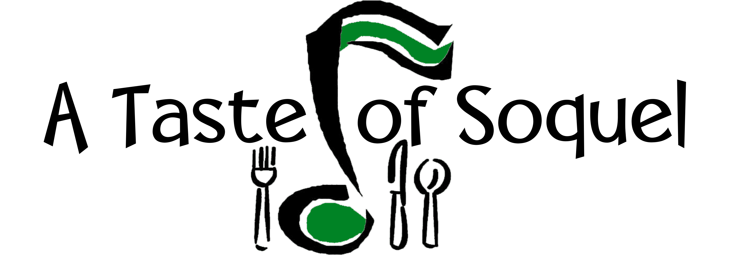
12th ANNUAL!

Food and Music for the Common Good

AN ALL NEW 2 Day ADVENTURE

Saturday & Sunday, September 26 & 27, 2020

Benefit for Second Harvest Food Bank

SOQUEL – WE’VE GOT YOUR BACK
Food and Music for the Common Good
Saturday & Sunday, September 26 & 27, 2020
It’s all happening at tasteofsoquel.org
A Taste of Soquel has raised over $94,038 (376,152 healthy meals) for families in Santa Cruz County! The TWELFTH Annual A Taste of Soquel (TOS) promises to be AN ALL NEW 2 DAY ADVENTURE for Food & Music for the Common Good! The Congregational Church of Soquel and the Capitola/Soquel Chamber of Commerce are co-sponsoring this online and food-to-go event to benefit for Second Harvest Food Bank and to support Soquel restaurants, wineries, and breweries.

Online Concert: There is something for everyone! Ralph Anybody, KPIG DJ, will emcee the online music by renowned musicians. This year A Taste of Soquel is pleased to feature an excellent variety of music bands to our stage! Each of them deserves top billing!
Saturday 1:30 pm: The Carolyn Sills Combo & Coffis Brothers
Sunday 1:30 pm: Slaid Cleaves & Rod Picott
Intermission both days: Musical Me Families Making Music with Camille Carter
SOQUEL – WE’VE GOT YOUR BACK
Time for us to give back! For the past 11 years Soquel Restaurants, Wineries and Breweries have supported A Taste of Soquel and Second Harvest with their delicious tastes and sips! This year they are offering A Taste of Soquel Specials all week-end! Stop by for some al fresco enjoyment or get your food and beverages to go. Either way, plan to order out! Let’s invite our friends, safe distance and enjoy A TRUE Taste of Soquel all weekend!

Local Restaurant participants: Sawasdee Thai Cuisine, HOME, Surf City Sandwiches, El Chipotle Taqueria, VinoCruz, Café Cruz, Pretty Good Advice, Tortilla Flats, Ugly Mug, Michael’s on Main, will be serving up specials all weekend!
Soquel Libations: Soquel Cider by Everett Family Farm, Discretion Brewing, Soquel Vineyards, Wargin Wines, Bargetto Winery, VinoCruz, and Poetic Cellars have weekend TOS offers for you!
Farm Fresh!: Featuring local, farm fresh tasting from Jeff Walls' Family Honey and fresh cider and produce from Everett Family Farm
KidZone: Check out the online concerts for Camille and Musical Me!
Up to the minute news, press release, photos for use and information can be found at http://www.tasteofsoquel.org or http://www.ccsoquel.org
Here's how it works this year:
Concerts: Saturday & Sunday, September 26 & 27, 2020, 1:30pm
Online at tasteofsoquel.org
Donations: We encourage donations (early and often ;-) at tasteofsoquel.org
“Tickets,” T-shirts, and caps available at brownpapertickets.com
Congregational Church of Soquel, 4951 Soquel Drive, Soquel, 831-475-2867
Tickets also available at http://www.brownpapertickets.com

Soquel – We’ve Got Your Back: Soquel restaurants, wineries, and breweries are offering A Taste of Soquel Specials all week-end! Stop by for some al fresco enjoyment or get your food and beverages to go. Either way, plan to order out and support Soquel!

GOAL: $6,000! If TOS donations reach $6,000, we will reach the milestone of $100,000 from 12 years of TOS Second Harvest Food Bank!

