PRESS RELEASE
Date: September 2023
From: Laura Hamby, Event Contact 831-325-9615 tasteofsoquel@gmail.com www.tasteofsoquel.org

Subject: TASTE OF SOQUEL, A Benefit for Second Harvest Food Bank

14th ANNUAL!
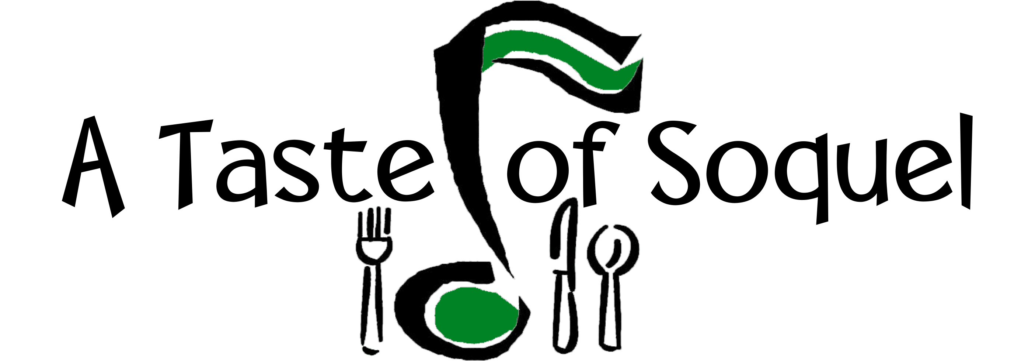
Food and Music for the Common Good
Saturday, September 23, 2023 Noon – 4pm

Benefit for Second Harvest Food Bank

A TASTE of SOQUEL
Food and Music for the Common Good
Saturday, September 23, 2023 Noon ~ 4pm

Benefit for Second Harvest Food Bank

A Taste of Soquel has raised over $ $106,631 (426,524 healthy meals) for families in Santa Cruz County! The 14th Annual A Taste of Soquel promises to be a fun filled day of Food & Music for the Common Good! The Congregational Church of Soquel and the Capitola/Soquel Chamber of Commerce are co-sponsoring this event to benefit Second Harvest Food Bank. Save the date and talk it up with your family and friends!

Live Music: There is something for everyone! Ralph Anybody, KPIG DJ, will emcee the live music by renowned local musicians. This year A Taste of Soquel is pleased to

feature an excellent variety of local music bands to our stage! Each of them deserves top billing!
12:15 pm Poi Rogers
1:30 pm Hank & Ella and the Fine Country Band
3:05 pm B Movie Kings

Local Restaurant participantsinclude: Sawasdee Thai Cuisine, HOME, El Chipotle Taqueria, VinoCruz, Café Cruz, and Tortilla Flats will be serving up food tastes especially prepared for this event.

Soquel Libations : Soquel Cider by Everett Family Farm, Discretion Brewing, Soquel Vineyards, Wargin Wines, Bargetto Winery, VinoCruz, , and Poetic Cellars will pour fan favorites!

Farm Fresh!: Featuring local, farm fresh tasting from Jeff Walls' Family Honey, fresh cider from Everett Family Farm, Soquel’s HomeGrown .

KidZone: The Kidzone is the place to be featuring music with Big Bill and Ibou!

Raffle: An annual favorite! Over 50 local businesses have donated raffle prizes. Raffle tickets will be available at the event. You need not be present to win.

You'll also want to check out the hospitality table with complimentary coffee, tea, lemonade, ice water and food offerings from the Bagelry, and Driscolls.

Up to the minute news, press release, photos for use and information can be found at http://www.tasteofsoquel.org.

Here's how it works! Purchase a wristband for an entire day of Food & Music for the Common Good! Pack up the neighborhood and join the rest of your family and friends at the 14th Annual A Taste of Soquel, a Benefit for Second Harvest Food Bank. See you there!

Saturday, September 23, 2023, Noon ~ 4pm
Congregational Church of Soquel, 4951 Soquel Drive, Soquel Donations:
$30 Adults Includes Music & Tasting at all Food & Libation Booths
$10 Youth Ages 12-20 (Music & Food Only)
Free Activities for Children ~ Courtesy Refreshments for all

Advance Tickets Available:
Congregational Church of Soquel, 4951 Soquel Drive, Soquel, 831-475-2867 Tickets also available at https://www.eventbrite.com/e/a-taste-of-soquel-tickets-713376497307?aff=oddtdtcreator

